SEC Form 4

FORM 4

Check this box if no longer subject to Section 16. Form 4 or Form 5 obligations may continue. See Instruction 1(b).

UNITED STATES SECURITIES AND EXCHANGE COMMISSION
Washington, D.C. 20549
 |  | OMB APPROVAL
STATEMENT OF CHANGES IN BENEFICIAL OWNERSHIP
 |  | OMB Number: | 3235-0287
 |  | Estimated average burden
Filed pursuant to Section 16(a) of the Securities Exchange Act of 1934 |  | hours per response: | 0.5
or Section 30(h) of the Investment Company Act of 1940
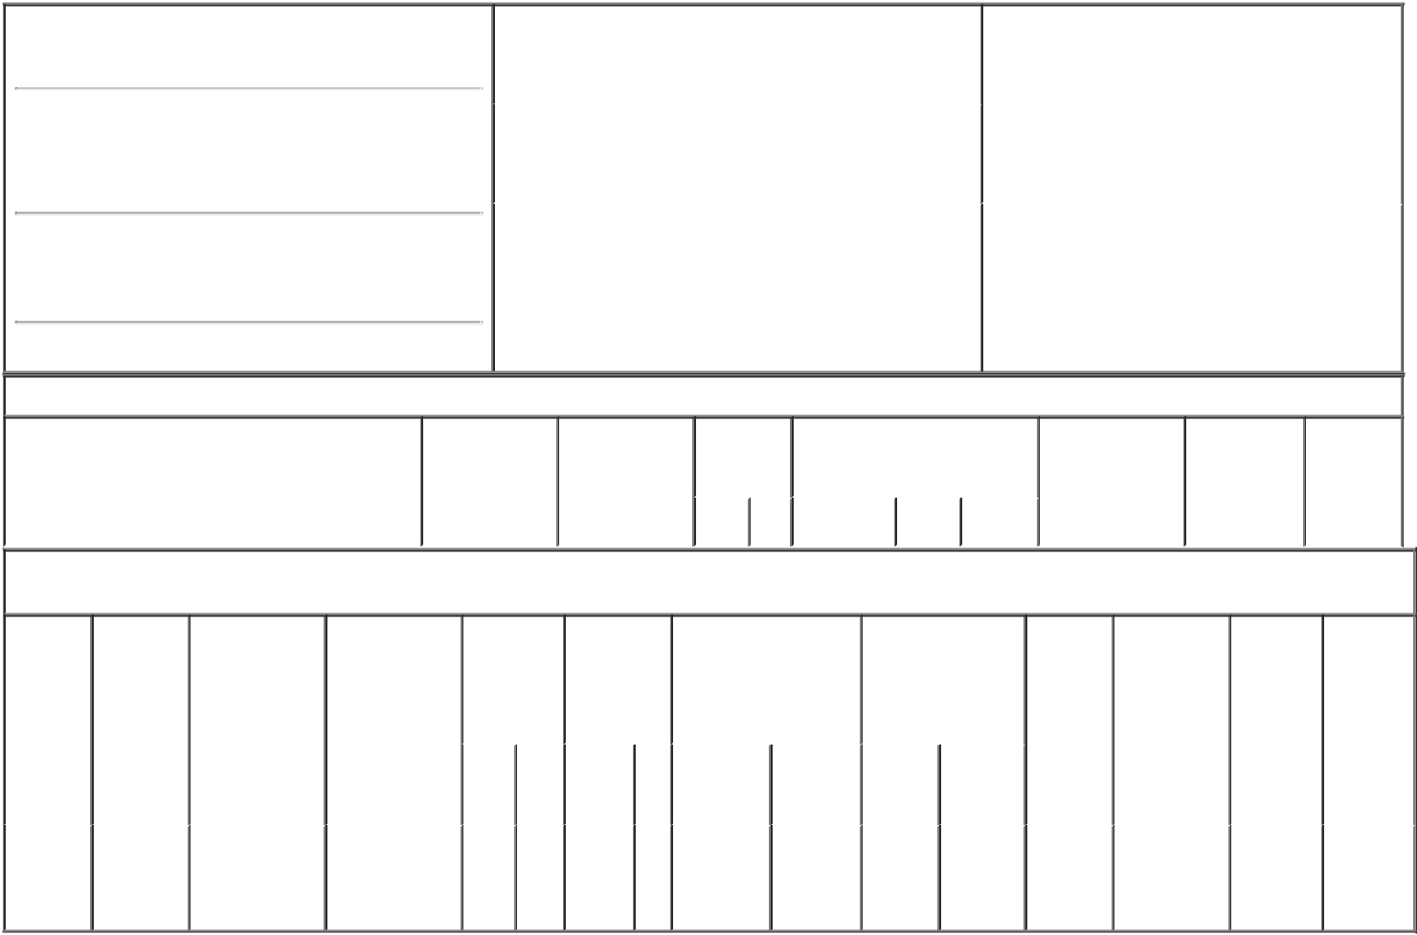

1. Name and Address of Reporting Person*
Meltz Mark A

(Last) (First) (Middle)

103 MONTGOMERY STREET, SUITE 150 THE PRESIDIO OF SAN FRANCISCO

(Street)

^{SAN} CA 94129 FRANCISCO

(City) (State) (Zip)

2. |  | Issuer Name and Ticker or Trading Symbol |  | 5. Relationship of Reporting Person(s) to Issuer
Kinnate Biopharma Inc. [ KNTE ] |  |  |  | (Check all applicable)
 |  |  |  |  | Director | 10% Owner
 |  |  |  | X | Officer (give title | Other (specify
 |  |  |  |  | below) | below)
3. |  | Date of Earliest Transaction (Month/Day/Year)
 |  |  |  |  | COO General Counsel Treasurer
02/11/2022
4. |  | If Amendment, Date of Original Filed (Month/Day/Year) |  | 6. Individual or Joint/Group Filing (Check Applicable
Line)
X Form filed by One Reporting Person

Form filed by More than One Reporting
Person

Table I - Non-Derivative Securities Acquired, Disposed of, or Beneficially Owned

1. Title of Security (Instr. 3) | 2. Transaction | 2A. Deemed | 3. | 4. Securities Acquired (A) or |  |  | 5. Amount of | 6. Ownership | 7. Nature of
 | Date | Execution Date, | Transaction | Disposed Of (D) (Instr. 3, 4 and 5) |  |  | Securities | Form: Direct | Indirect
 | (Month/Day/Year) | if any | Code (Instr. |  |  |  | Beneficially | (D) or Indirect | Beneficial
 |  | (Month/Day/Year) | 8) |  |  |  | Owned Following | (I) (Instr. 4) | Ownership
 |  |  |  |  |  |  | Reported |  | (Instr. 4)
 |  |  | Code V | Amount | (A) or | Price | Transaction(s)
 |  |  |  |  | (D) |  | (Instr. 3 and 4)

Table II - Derivative Securities Acquired, Disposed of, or Beneficially Owned

(e.g., puts, calls, warrants, options, convertible securities)

1. Title of | 2. | 3. Transaction | 3A. Deemed | 4. | 5. Number of |  | 6. Date Exercisable and |  | 7. Title and Amount |  | 8. Price of | 9. Number of | 10. | 11. Nature
Derivative | Conversion | Date | Execution Date, | Transaction | Derivative |  | Expiration Date |  | of Securities |  | Derivative | derivative | Ownership | of Indirect
Security | or Exercise | (Month/Day/Year) | if any | Code (Instr. | Securities |  | (Month/Day/Year) |  | Underlying |  | Security | Securities | Form: | Beneficial
(Instr. 3) | Price of |  | (Month/Day/Year) | 8) | Acquired (A) |  |  |  | Derivative Security |  | (Instr. 5) | Beneficially | Direct (D) | Ownership
 | Derivative |  |  |  | or Disposed |  |  |  | (Instr. 3 and 4) |  |  | Owned | or Indirect | (Instr. 4)
 | Security |  |  |  | of (D) (Instr. |  |  |  |  |  |  | Following | (I) (Instr. 4)
 |  |  |  |  | 3, 4 and 5) |  |  |  |  |  |  | Reported
 |  |  |  |  |  |  |  |  |  |  |  | Transaction(s)
 |  |  |  |  |  |  |  |  |  | Amount |  | (Instr. 4)
 |  |  |  |  |  |  |  |  |  | or
 |  |  |  |  |  |  | Date | Expiration |  | Number
 |  |  |  | Code V | (A) | (D) | Exercisable | Date | Title | of Shares
Employee
Stock |  |  |  |  |  |  | (1) |  | Common | 135,000
Option | $10.03 | 02/11/2022 |  | A | 135,000 |  |  | 02/11/2032 |  |  | $0.00 | 135,000 | D
(right to |  |  |  |  |  |  |  |  | Stock
buy)

Explanation of Responses:

- One forty-eighth (1/48th) of the total number of shares granted under the Option shall vest and become exercisable starting on March 1, 2022 (the "Vesting Commencement Date") and thereafter each month on the same day of the month as the Vesting Commencement Date, until all shares subject to the Option have vested on February 1, 2026, subject to the Reporting Person continuing to be a service provider through each such date.

Remarks:

/s/ Mark A. Meltz |  | 02/15/2022
** Signature of Reporting Person |  | Date

Reminder: Report on a separate line for each class of securities beneficially owned directly or indirectly.

* If the form is filed by more than one reporting person, see Instruction 4 (b)(v).

- Intentional misstatements or omissions of facts constitute Federal Criminal Violations See 18 U.S.C. 1001 and 15 U.S.C. 78ff(a). Note: File three copies of this Form, one of which must be manually signed. If space is insufficient, see Instruction 6 for procedure.
Persons who respond to the collection of information contained in this form are not required to respond unless the form displays a currently valid OMB Number.

